Amazing!

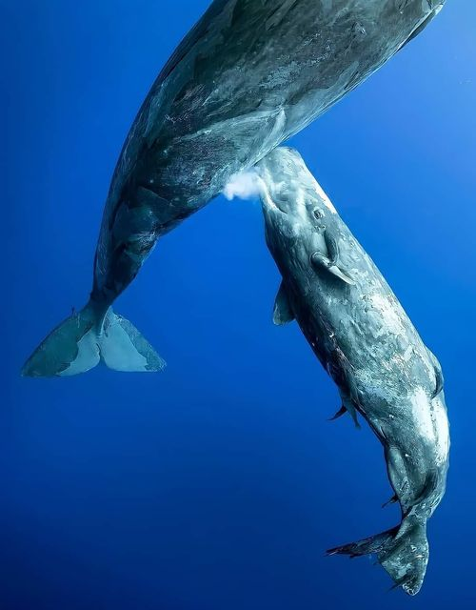

Dr Muhammad Salah

June 8
" Indeed, all things We created with predestination."
While diving in the Indian Ocean, Russian photographer "Mike Korostelev" captured this wonderful picture of a female "sperm whale" releasing milk into the water to breastfeed her young
It's not random at all!!
Baby sperm whales breastfeed in this way because the anatomical structure of their mouth does not support feeding naturally.
But how does milk settle underwater without drifting?
The reason for the composition of milk itself, which contains a large proportion of fat, so its thick texture allows the baby sperm whale to pick it up from the water easily..

